Bibiana Obler

Münter, Gabriele (1877–1962)

Gabriele Münter was a key figure in German Expressionism. Born in Berlin, she moved to Munich in 1901 where she became an active participant in the Neue Künstlervereinigung München (NKVM) (Munich New Artists’ Association), founded in 1909, and then the Blue Rider, in 1911. Known primarily for her painting, she was also a prolific graphic artist and photographer. Like many women of her generation, she received her art education through a combination of private lessons, women's art schools, and new co-educational institutions, in her case, the Phalanx School, where she studied with Wassily Kandinsky. The latter encounter proved momentous for both artists: by 1903, they were engaged (secretly at first) and remained in a relationship until 1916. During these years, both Münter and Kandinsky developed their mature styles. Expressionism in southern Germany, unlike Die Brücke in the north, fostered a collegial environment comprising both women and men. Münter's painting changed dramatically in 1908 during a vacation the couple took in Murnau with Marianne von Werefkin and Alexej Jawlensky. Münter attributed her shift towards Fauvism to Jawlensky's interest in Matisse and the Nabis, to the Bavarian landscape, and to the inspiration of Hinterglasmalerei (reverse-glass painting).

Like most of her colleagues in German Expressionism, with the exception of Kandinsky, Münter focused on figuration rather than abstraction. These artists shared a keen concern for the relationship between artist, viewer, and artwork. For Münter, painting was a way to explore barriers between self and other. In still lifes, landscapes, portraits, and genre scenes, she attended to what sometimes appears insuperable distance between discrete entities but also suggested, on occasion, the possibility of a kind of togetherness. Her Still Life with Queen, for example, portrays a scraggly bouquet that both blocks and frames our access to the eponymous queen, whose dimensions in relation to the flowers suggest her identity as a doll even as Münter allows an element of uncertainty: is this a portrait of an actual queen on a dais in the far background? An apparition? Or, indeed, as those familiar with Münter's home might suspect, a gift from the dancer Alexander Sacharoff? The painting unsettles assumptions about clear distinctions between person and object, reality and fantasy, and even masculinity and femininity (if we factor in Sacharoff's proclivity for cross-dressing).

Münter acquired an international reputation through solo and group exhibitions in France, Germany, Japan, Russia, and so on. She lived for an extended period in Sweden and Denmark during World War I and maintained her international profile and involvement with Expressionism during the Weimar Republic, participating in exhibitions of the November Group (1921) and of the Blue Rider (USA, 1926). She continued to exhibit through the first years of the Third Reich: encouraged by her companion Johannes Eichner, whom she had met in 1927, she concentrated on subjects that appealed to the regime and participated in the 1936 traveling "Adolf Hitler's Streets in Art." During World War II, however, she kept a low profile. Public acclaim returned after the war with a retrospective at the Städtische Galerie im Lenbachhaus (1949) and representation at the 25th Venice Biennale (1950) and the first documenta in Kassel (1955).

References and further reading

Behr, Shulamith and Annegret Hoberg. Gabriele Münter: The Search for Expression 1906-1917. London: Courtauld, 2005.

Heller, Reinhold. Gabriele Münter: The Years of Expressionism 1903-1920. Munich: Prestel, 1997.

Hoberg, Annegret. Wassily Kandinsky and Gabriele Münter: Letters and Reminiscences 1902-1914. Ian Robson, trans. Munich: Prestel, 1994.

Hoberg, Annegret and Helmut Friedel, eds. Gabriele Münter 1877-1962 Retrospektive. Munich: Prestel, 1992.

Obler, Bibiana. Intimate Collaborations: Kandinsky and Münter, Arp and Taeuber. New Haven: Yale University Press, 2014.

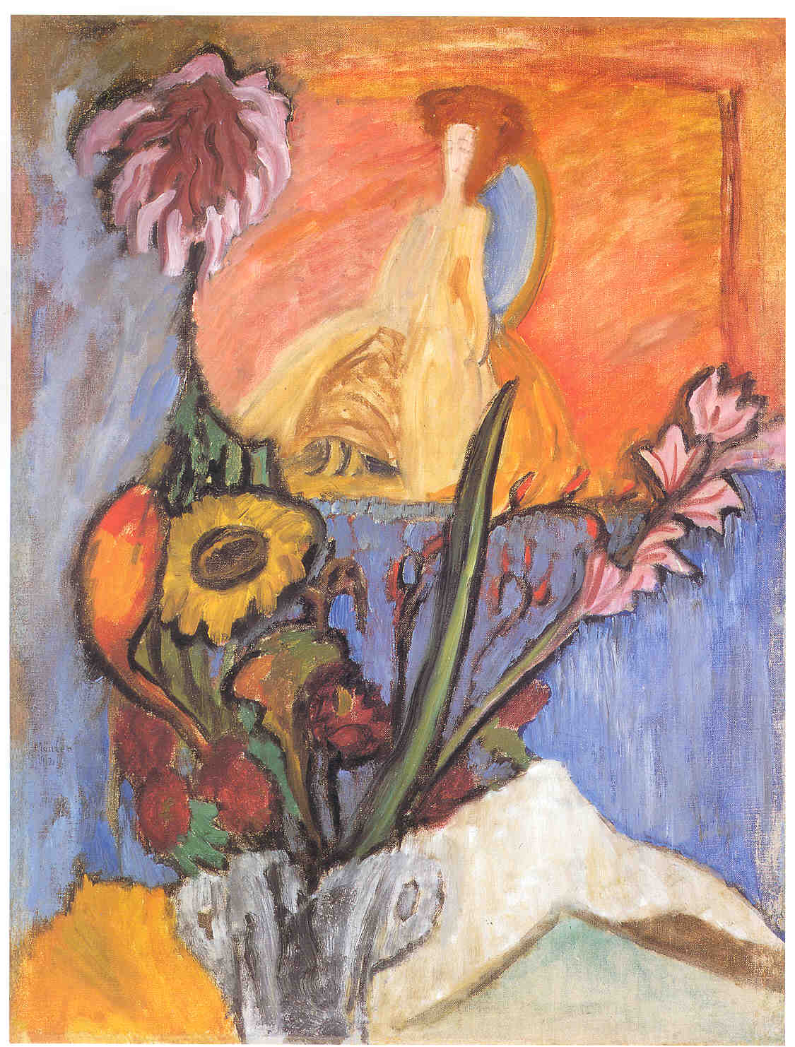

Image: Gabriele Münter, Still Life with Queen, 1912. Oil on canvas, 27 7/16 × 19 5/16 in. (69.8 x 49 cm). Arthur Jerome Eddy Memorial Collection, 1931.521, The Art Institute of Chicago.

http://www.artic.edu/aic/collections/artwork/9018?search_no=2&index=0

